**HAMMING CODE ENCODER**

**TEAM MEMBERS**

**1.Arya Jestin**

**2.Jishnu SS**

**3.Megha K**

**4.Prasoon P**

**Hamming Codes** Are a Type of Error-Correcting Code Used in Digital Communication to Detect and Correct Errors in Transmitted Data. Named After Mathematician Richard Hamming, These Codes Add Extra Bits to The Original Data to Create a Structured Code That Can Identify and Fix Errors That Occur During Transmission. Hamming Codes Operate Based on The Concept of Parity, With Additional Bits Providing Redundancy That Helps in Error Detection and Correction. By Using a Specific Pattern for The Arrangement of These Parity Bits, Errors Can Be Pinpointed and Corrected Without the Need to Retransmit the Entire Data.

**Below is a 4-Bit Hamming Code Encoder Logic Circuit [Odd Parity]**

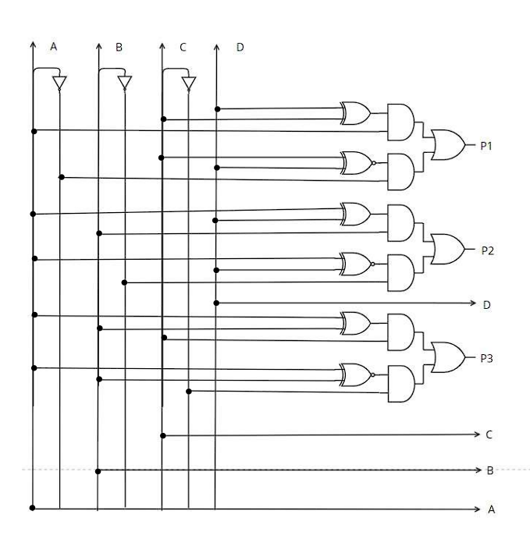

VERILOG CODE

module encoder2(a,b,c,d, p1,p2,e,p3,f,g,h);

input a,b,c,d;

output p1,p2,e,p3,f,g,h;

wire w1,w2,w3,w4,w5,w6,w7,w8,w9,w10,w11,w12,w13,w14,w15;

not a_not(w1,a);

not b_not(w2,b);

not c_not(w3,c);

xor cd(w4,c,d);

xor ad(w6,a,d);

xor ab(w8,a,b);

xnor cdx(w5,c,d);

xnor adx(w7,a,d);

xnor abx(w9,a,b);

and w4a(w10,w4,a);

and w1w5(w11,w1,w5);

and w6b(w12,w6,b);

and w7w2(w13,w7,w2);

and w8c(w14,w8,c);

and w9w3(w15,w9,w3);

or p11(p1,w10,w11);

or p22(p2,w12,w13);

assign e=d;

or p33(p3,w14,w15);

assign f=c;

assign g=b;

assign h=a;

endmodule

TEST BENCH

module hammingtb();

reg a,b,c,d;

wire p1,p2,p3;

encoder2 dut(a,b,c,d,p1,p2,e,p3,f,g,h);

initial begin

a=0;b=1;c=1;d=0;#100

a=1;b=1;c=0;d=1;#100

a=1;b=0;c=1;d=1;#100

a=0;b=0;c=0;d=1;#100

a=1;b=1;c=1;d=1;#100

a=0;b=1;c=0;d=1;

end

endmodule

OUTPUT WAVEFORM

